Rules

* The questions are MCQ types. Each question carries equal marks. The time allotted is 120 minutes.
* There is no negative marking for any wrong answer.
* There is only one option correct for each question.
* Once an answer is submitted for a question, the participant is not allowed to visit the question again.

In this skilltest, we will take a case study approach; we will try to go through each and every aspect of Decision tree and try to understand it in more depth. Note that the first 8 questions are very basic, and targeted to evaluate that you know at least the basics. After the first 8 questions, questions will be randomly asked on topics pertaining tree based algorithms.

Topics covered:

Decision Tree

Random Forest

Gradient Boosting

Total number of questions: 45

**Thank You for participating in Skilltest: Tree Based Algorithms**

**Your score is : 24.0**

**See** [**https://datahack.analyticsvidhya.com/contest/skilltest-tree-based-algorithms/lb**](https://datahack.analyticsvidhya.com/contest/skilltest-tree-based-algorithms/lb)

More than 400 people participated in the skill test and the highest score obtained was 36. Here are a few statistics about the distribution.

Mean Score : 16.98

Median Score : 19

Mode Score : 19

Questions and Solutions

**Q 1) The data scientists at “BigMart Inc” have collected 2013 sales data for 1559 products across 10 stores in different cities. Also, certain attributes of each product based on these attributes and store have been defined. The aim is to build a predictive model and find out the sales of each product at a particular store during a defined period.**

**Which learning problem does this belong to?**

1. Supervised learning
2. Unsupervised learning
3. Reinforcement learning
4. None

**Solution: A**

Supervised learning is the machine learning task of inferring a function from labeled training data. Here historical sales data is our training data and it contains the labels / outcomes.

**Q2) Before building our model, we first look at our data and make predictions manually. Suppose we have only one feature as an independent variable (Outlet\_Location\_Type) along with a continuous dependent variable (Item\_Outlet\_Sales).**

| **Outlet\_Location\_Type** | **Item\_Outlet\_Sales** |
| --- | --- |
| Tier 1 | 3735.14 |
| Tier 3 | 443.42 |
| Tier 1 | 2097.27 |
| Tier 3 | 732.38 |
| Tier 3 | 994.71 |

**We see that we can possibly differentiate in Sales based on location (tier 1 or tier 3). We can write simple if-else statements to make predictions.**

**Which of the following models could be used to generate predictions (may not be most accurate)?**

1. if “Outlet\_Location” is “Tier 1”: then “Outlet\_Sales” is 2000, else “Outlet\_Sales” is 1000
2. if “Outlet\_Location” is “Tier 1”: then “Outlet\_Sales” is 1000, else “Outlet\_Sales” is 2000
3. if “Outlet\_Location” is “Tier 3”: then “Outlet\_Sales” is 500, else “Outlet\_Sales” is 5000
4. Any of the above

**Solution: D**

All the options would be correct. All the above models give a prediction as output and here we are not talking about most or least accurate.

**Q3) The below created if-else statement is called a decision stump:**

**Our model: if “Outlet\_Location” is “Tier 1”: then “Outlet\_Sales” is 2000, else “Outlet\_Sales” is 1000**

**Now let us evaluate the model we created above on following data:**

**Evaluation Data:**

| **Outlet\_Location\_Type** | **Item\_Outlet\_Sales** |
| --- | --- |
| Tier 1 | 3735.1380 |
| Tier 3 | 443.4228 |
| Tier 1 | 2097.2700 |
| Tier 3 | 732.3800 |
| Tier 3 | 994.7052 |

**We will calculate RMSE to evaluate this model.**

**The root-mean-square error (RMSE) is a measure of the differences between values predicted by a model or an estimator and the values actually observed.**

**The formula is :**

rmse = (sqrt(sum(square(predicted\_values - actual\_values)) / number of observations))

**What would be the RMSE value for this model?**

1. ~23
2. ~824
3. ~680318
4. ~2152

**Solution: B**

[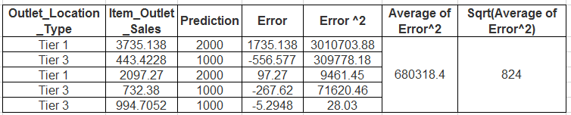](https://www.analyticsvidhya.com/wp-content/uploads/2016/12/Capture89.png)

So by calculating RMSE value using the formula above, we get ~824 as our answer.

**Q4) For the same data, let us evaluate our models. The root-mean-square error (RMSE) is a measure of the differences between values predicted by a model or an estimator and the values actually observed.**

| **Outlet\_Location\_Type** | **Item\_Outlet\_Sales** |
| --- | --- |
| Tier 1 | 3735.1380 |
| Tier 3 | 443.4228 |
| Tier 1 | 2097.2700 |
| Tier 3 | 732.3800 |
| Tier 3 | 994.7052 |

**The formula is :**

rmse = (sqrt(sum(square(predicted\_values - actual\_values)) / num\_samples))

**Which of the following will be the best model with respect to RMSE scoring?**

1. if “Outlet\_Location\_Type” is “Tier 1”: then “Outlet\_Sales” is 2000, else “Outlet\_Sales” is 1000
2. if “Outlet\_Location\_Type” is “Tier 1”: then “Outlet\_Sales” is 1000, else “Outlet\_Sales” is 2000
3. if “Outlet\_Location\_Type” is “Tier 3”: then “Outlet\_Sales” is 500, else “Outlet\_Sales” is 5000
4. if “Outlet\_Location\_Type” is “Tier 3”: then “Outlet\_Sales” is 2000, else “Outlet\_Sales” is 200

**Solution: A**

Calculate the RMSE value for each if-else model:

1. RMSE value of the model: 824.81
2. RMSE value of the model: 1656.82
3. RMSE value of the model: 1437.19
4. RMSE value of the model: 2056.07

We see that the model in option A has the lowest value and lower the RMSE, better the model.

**Q5) Now let’s take multiple features into account.**

| **Outlet\_Location\_Type** | **Outlet\_Type** | **Item\_Outlet\_Sales** |
| --- | --- | --- |
| Tier 1 | Supermarket Type1 | 3735.1380 |
| Tier 3 | Supermarket Type2 | 443.4228 |
| Tier 1 | Supermarket Type1 | 2097.2700 |
| Tier 3 | Grocery Store | 732.3800 |
| Tier 3 | Supermarket Type1 | 994.7052 |

**If have multiple if-else ladders, which model is best with respect to RMSE?**

if “Outlet\_Location\_Type” is 'Tier 1':

   return 2500

else:

   if “Outlet\_Type” is 'Supermarket Type1':

       return 1000

   elif “Outlet\_Type” is 'Supermarket Type2':

       return 400

   else:

       return 700

if "Outlet\_Location\_Type" is 'Tier 3':

return 2500

else:

if "Outlet\_Type" is 'Supermarket Type1':

return 1000

elif "Outlet\_Type" is 'Supermarket Type2':

return 400

else:

return 700

if "Outlet\_Location\_Type" is 'Tier 3':

return 3000

else:

if "Outlet\_Type" is 'Supermarket Type1':

return 1000

else:

return 500

if "Outlet\_Location\_Type" is 'Tier 1':

return 3000

else:

if "Outlet\_Type" is 'Supermarket Type1':

return 1000

else:

return 450

**Solution: D**

1. RMSE value: 581.50
2. RMSE value: 1913.36
3. RMSE value: 2208.36
4. RMSE value: 535.75

We see that option D has the lowest value

**Q6) Till now, we have just created predictions using some intuition based rules. Hence our predictions may not be optimal.What could be done to optimize the approach of finding better predictions from the given data?**

1. Put predictions which are the sum of all the actual values of samples present. For example, in “Tier 1”, we have two values 3735.1380 and 2097.2700, so we will take ~5832 as our prediction
2. Put predictions which are the difference of all the actual values of samples present. For example, in “Tier 1”, we have two values 3735.1380 and 2097.2700, so we will take ~1638 as our prediction
3. Put predictions which are mean of all the actual values of samples present. For example, in “Tier 1”, we have two values 3735.1380 and 2097.2700, so we will take ~2916 as our prediction

**Solution: C**

We will take that value which is more representative of the data. Given all three options, central tendency, mean value would be a better fit for the data.

**Q7) We could improve our model by selecting the feature which gives a better prediction** **when we use it for splitting (It is a process of dividing a node into two or more sub-nodes).**

| **Outlet\_Location\_Type** | **Item\_Fat\_Content** | **Item\_Outlet\_Sales** |
| --- | --- | --- |
| Tier 1 | Low Fat | 3735.1380 |
| Tier 3 | Regular | 443.4228 |
| Tier 1 | Low Fat | 2097.2700 |
| Tier 3 | Regular | 732.3800 |
| Tier 3 | Low Fat | 994.7052 |

**In this example, we want to find which feature would be better for splitting root node (entire population or sample and this further gets divided into two or more homogeneous sets).**

**Assume splitting method is “Reduction in Variance” i.e. we split using a variable, which results in overall lower variance.**

[q7_image](https://www.analyticsvidhya.com/wp-content/uploads/2016/11/Q7_Image.jpg)

**What is the resulting variance if we split using Outlet\_Location\_Type?**

1. ~298676
2. ~298676
3. ~3182902
4. ~2222733
5. None of these

**Solution: A**

Option A is correct. The steps to solve this problem are:

* Calculate mean of target value for “Tier 1” and then find the variance of each of the target values of “Tier 1”
* Similarly calculate the variance for “Tier 3”
* Find weighted mean of variance of “Tier 1” and “Tier 3” (above calculated values).

P.S. You will need to take weigthed mean.

**Q8) Next, we want to find which feature would be better for splitting root node (where root node represents entire population). For this, we will set “Reduction in Variance” as our splitting method.**

| Outlet\_Location\_Type | Item\_Fat\_Content | Item\_Outlet\_Sales |
| --- | --- | --- |
| Tier 1 | Low Fat | 3735.1380 |
| Tier 3 | Regular | 443.4228 |
| Tier 1 | Low Fat | 2097.2700 |
| Tier 3 | Regular | 732.3800 |
| Tier 3 | Low Fat | 994.7052 |

**The split with lower variance is selected as the criteria to split the population.**

[q8_image](https://www.analyticsvidhya.com/wp-content/uploads/2016/11/Q8_Image.jpg)

**Among Between Outlet\_Location\_Type and Item\_Fat\_Content, which was a better feature to split?**

1. Outlet\_Location\_Type
2. Item\_Fat\_Content
3. will not split on both

**Solution: A**

Option A is correct because Outlet\_Location\_Type has more reduction in variance. You can perform calculation similar to last question.

**Q9) Look at the below image: The red dots represent original data input, while the green line is the resultant model.**

[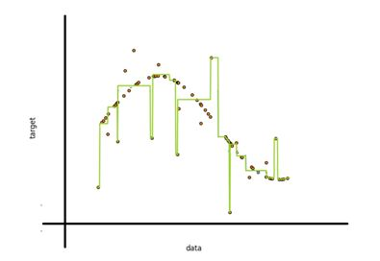](https://www.analyticsvidhya.com/wp-content/uploads/2016/11/Q9_Image.jpg)

**How do you propose to make this model better while working with decision tree?**

1. Let it be. The model is general enough
2. Set the number of nodes in the tree beforehand so that it does not overdo its task
3. Build a decision tree model, use cross validation method to tune tree parameters
4. Both B and C
5. All A, B and C
6. None of these

**Solution: C**

A. As we can see in the image, our model is not general enough, it takes outliers/ noise into account when calculating predictions which makes it overfit the data.

B. If we can set the number of nodes, we could easily get an optimal tree. But to select this value optimally beforehand is very hard, as it requires extensive cross-validation to be generalizable.

C. Tuning Tree parameters is the best method to ensure generalizability

**Q10)** **Which methodology does Decision Tree (ID3) take to decide on first split?**

1. Greedy approach
2. Look-ahead approach
3. Brute force approach
4. None of these

**Solution: A**

The process of top-down induction of decision trees (TDIDT) is an example of a greedy algorithm, and it is by far the most common strategy for learning decision trees from data. Read [here](https://en.wikipedia.org/wiki/Decision_tree_learning).

**Q11) There are 24 predictors in a dataset. You build 2 models on the dataset:**

**1. Bagged decision trees and**  
**2. Random forest**

**Let the number of predictors used at a single split in bagged decision tree is A and Random Forest is B.**

**Which of the following statement is correct?**

1. A >= B
2. A < B
3. A >> B
4. Cannot be said since different iterations use different numbers of predictors

**Solution: A**

Random Forest uses a subset of predictors for model building, whereas bagged trees use all the features at once.

**Q12)** **Why do we prefer information gain over accuracy when splitting**?

1. Decision Tree is prone to overfit and accuracy doesn’t help to generalize
2. Information gain is more stable as compared to accuracy
3. Information gain chooses more impactful features closer to root
4. All of these

**Solution: D**

All the above options are correct

**Q13) Random forests (While solving a regression problem) have the higher variance of predicted result in comparison to Boosted Trees (Assumption: both Random Forest and Boosted Tree are fully optimized).**

1. True
2. False
3. Cannot be determined

**Solution: B**

Random Forest have lower variance than boosted trees because random forest essentially ensembles many uncorrelated decision trees and it is less complex compare to boosted tree model. Higher the complexity higher the variance.

**Q14) Assume everything else remains same, which of the following is the right statement about the predictions from decision tree in comparison with predictions from Random Forest and Boosted Decision Tree?**

1. Lower Variance, Lower Bias
2. Lower Variance, Higher Bias
3. Higher Variance, Higher Bias
4. Lower Bias, Higher Variance

**Solution: D**

Decision Trees have low Bias but high Variance when compared to Random Forests and Boosted decision trees because decision tree is less complex model (Single tree) compared to Random Forest and Boosted Decision Trees (Ensemble of multiple trees).

**Q15)** **Which of the following tree based algorithm uses some parallel (full or partial) implementation?**

1. Random Forest
2. Gradient Boosted Trees
3. XGBOOST
4. Both A and C
5. A, B and C

**Solution: E**

Only Random Forest and XGBoost have parallel implementations.

Random Forest is very easy to parallelise, where as XGBoost can have partially parallel implementation. In Random Forest, all trees grows parallel and finally ensemble the output of each tree .

Xgboost doesn’t run multiple trees in parallel like Random Forest, you need predictions after each tree to update gradients. Rather it does the parallelization WITHIN a single tree to create branches independently.

**Q16) Which of the following could not be result of two-dimensional feature space from natural recursive binary split?**

[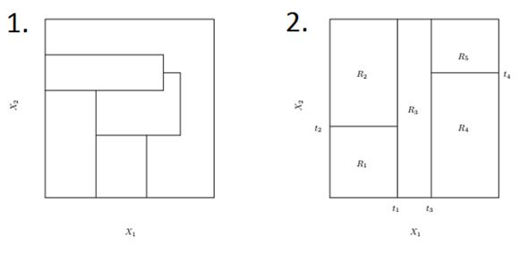](https://www.analyticsvidhya.com/wp-content/uploads/2016/11/Q16_Image.jpg)

1. 1 only
2. 2 only
3. 1 and 2
4. None

**Solution: B**

1 is not possible. Therefore, Option B is correct. For more details, refer to Page 308 from ELSI (Elements of Statistical Learning).

**Q17)** **Which of the following is not possible in a boosting algorithm?**

1. Increase in training error.
2. Decrease in training error
3. Increase in testing error
4. Decrease in testing error
5. Any of the above

**Solution: A**

Boosted algorithms minimize error in previously predicted values by last estimator. So it always decreases training error.

**Q18) Which of the following is a decision boundary of Decision Tree?**  
[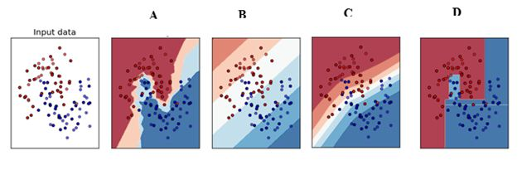](https://www.analyticsvidhya.com/wp-content/uploads/2016/11/Q18_Image.jpg)

1. B
2. A
3. D
4. C
5. Can’t Say

**Solution: C**

Decision Boundaries of decision trees are always perpendicular to X and Y axis.

**Q19) Let’s say we have m numbers of estimators (trees) in a boosted tree. Now,** **how many intermediate trees will work on modified version (OR weighted) of data set?**

1. 1
2. m-1
3. m
4. Can’t say
5. None of the above

**Solution: B**

The first tree in boosted trees works on the original data, whereas all the rest work on modified version of the data.

**Q20) Boosted decision trees perform better than Logistic Regression on anomaly detection problems (Imbalanced Class problems).**

1. True, because they give more weight for lesser weighted class in successive rounds
2. False, because boosted trees are based on Decision Tree, which will try to overfit the data

**Solution: A**

Option A is correct

**Q21) Provided n < N and m < M. A Bagged Decision Tree with a dataset of N rows and M columns uses\_\_\_\_rows and \_\_\_\_ columns for training an individual intermediate tree.**

1. N, M
2. N, M
3. n, M
4. n, m

**Solution: C**

Bagged trees uses all the columns for only a sample of the rows. So randomization is done on the number of observations not on number of columns.

**Q22)** **Given 1000 observations, Minimum observation required to split a node equals to 200 and minimum leaf size equals to 300 then what could be the maximum depth of a decision tree?**

1. 1
2. 2
3. 3
4. 4
5. 5

**Solution: B**

The leaf nodes will be as follows:

[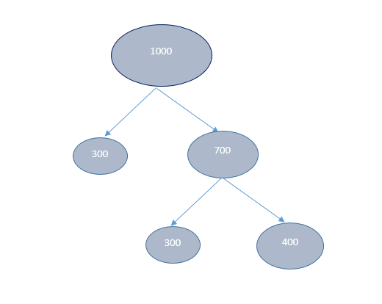](https://www.analyticsvidhya.com/wp-content/uploads/2016/12/Capture78.png)

So only after 2 split, the tree is created. Therefore depth is 2.

**Q23) Consider a classification tree for whether a person watches ‘Game of Thrones’ based on features like age, gender, qualification and salary. Is it possible to have following leaf node?**

[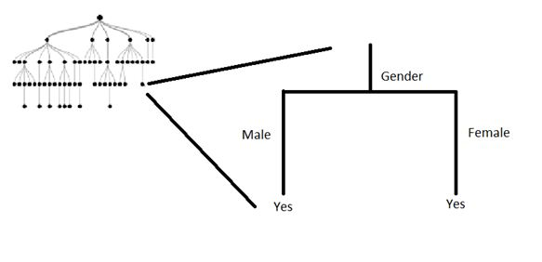](https://www.analyticsvidhya.com/wp-content/uploads/2016/11/Q25_Image.jpg)

1. Yes
2. No
3. Can’t say

**Solution: A**

A node can be split on a feature, as long as it gives information after split. So even though the above split does not reduce the classification error, it improves the Gini index and the cross-entropy. Refer Pg. 314 of ISLR.

**Q24)** **Generally, in terms of prediction performance which of the following arrangements are correct:**

1. Bagging>Boosting>Random Forest>Single Tree
2. Boosting>Random Forest>Single Tree>Bagging
3. Boosting>Random Forest>Bagging>Single Tree
4. Boosting >Bagging>Random Forest>Single Tree

**Solution: C**

Generally speaking, Boosting algorithms will perform better than bagging algorithms. In terms of bagging vs random forest, random forest works better in practice. And it’s always true that ensembles of algorithms are better than single models

**Q25)** **In which of the following application(s), a tree based algorithm can be applied successfully?**

1. Recognizing moving hand gestures in real time
2. Predicting next move in a chess game
3. Predicting sales values of a company based on their past sales
4. A and B
5. A, B, and C

**Solution: E**

Option E is correct as we can apply tree based algorithm in all the 3 scenarios.

**Q26) When using Random Forest for feature selection, suppose you permute values of two features – A and B. Permutation is such that you change the indices of individual values so that they do not remain associated with the same target as before.**

**For example:**

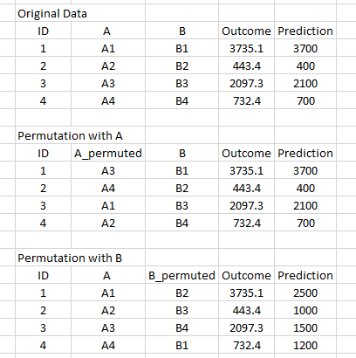

**You notice that permuting values does not affect the score of**model**built on A, whereas the score decreases on the model trained on B.Which of the following features would you select from the following solely based on the above finding?**

1. (A)
2. (B)

**Solution: B**

This is called mean decrease in accuracy when using random forest for feature selection. Intuitively, if shuffling the values is not impacting the predictions, the feature is unlikely to add vvalue.

**Q27)** **Boosting is said to be a good classifier because:**

1. It creates all ensemble members in parallel, so their diversity can be boosted.
2. It attempts to minimize the margin distribution
3. It attempts to maximize the margins on the training data
4. None of these

**Solution: B**

Only option B is correct

**Q28) Which splitting algorithm is better with categorical variable having high cardinality?**

1. Information Gain
2. Gain Ratio
3. Change in Variance
4. None of these

**Solution: B**

When high cardinality problems, gain ratio is preferred over any other splitting technique

**Q29) There are “A” features in a dataset and a Random Forest model is built over it. It is given that there exists only one significant feature of the outcome – “Feature1”.What would be the % of total splits that will not consider the “Feature1” as one of the features involved in that split (It is given that m is the number of maximum features for random forest)?**

**Note: Considering random forest select features space for every node split.**

1. (A-m)/A
2. (m-A)/m
3. m/A
4. Cannot be determined

**Solution: A**

Option A is correct. This can be considered as permutation of not selecting a predictor from all the possible predictors

**Q30) Suppose we have missing values in our data. Which of the following method(s) can help us to deal with missing values while building a decision tree?**

1. Let it be. Decision Trees are not affected by missing values
2. Fill dummy value in place of missing, such as -1
3. Impute missing value with mean/median
4. All of these

**Solution: D**

All the options are correct

**Q31) To reduce under fitting of a Random Forest model, which of the following method can be used?**

1. Increase minimum sample leaf value
2. increase depth of trees
3. Increase the value of minimum samples to split
4. None of these

**Solution: B**

Only option B is correct, because

A: increasing the number of samples for a leaf will reduce the depth of a tree, indirectly increasing underfitting

B: Increasing depth will definitely decrease help reduce underfitting

C: increasing the number of samples considered to split will have no effect, as the same information will be given to the model.

Therefore B is True.

**Q32)** **While creating a Decision Tree, can we reuse a feature to split a node?**

1. Yes
2. No

**Solution: A**

Yes, decision tree recursively uses all the features at each node.

**Q33)** **Which of the following is a mandatory data pre-processing step(s) for XGBOOST?**

1. **Impute Missing Values**
2. **Remove Outliers**
3. **Convert data to numeric array / sparse matrix**
4. **Input variable must have normal distribution**
5. **Select the sample of records for each tree/ estimators**
6. 1 and 2
7. 1, 2 and 3
8. 3, 4 and 5
9. 3
10. 5
11. All

**Solution: D**

XGBoost is doesn’t require most of the pre-processing steps, so only converting data to numeric is required among of the above listed steps

**Q34)** **Decision Trees are not affected by multicollinearity in features:**

1. TRUE
2. FALSE

**Solution: A**

The statement is true. For example, if there are two 90% correlated features, decision tree would consider only one of them for splitting.

**Q35)** **For parameter tuning in a boosting algorithm, which of the following search strategies may give best tuned model:**

1. Random Search.
2. Grid Search.
3. A or B
4. Can’t say

**Solution: C**

Both random search or grid search may give best tuned model.

**Q36) Imagine a two variable predictor space having 10 data points. A decision tree is built over it with 5 leaf nodes. The number of distinct regions that will be formed in predictors space?**

1. 25
2. 10
3. 2
4. 5

**Solution: D**

The predictor space will be divided into 5 regions. Therefore, option D is correct.

**Q37)** **In Random Forest, which of the following is randomly selected?**

1. Number of decision trees
2. features to be taken into account when building a tree
3. samples to be given to train individual tree in a forest
4. B and C
5. A, B and C

**Solution: D**

Option A is False because, number of trees has to decided when building a tree. It is not random.

Options B and C are true

**Q38)** **Which of the following are the disadvantage of Decision Tree algorithm?**

1. Decision tree is not easy to interpret
2. Decision tree is not a very stable algorithm
3. Decision Tree will over fit the data easily if it perfectly memorizes it
4. Both B and C

**Solution: D**

Option A is False, as decision tree are very easy to interpret

Option B is True, as decision tree are high unstable models

Option C is True, as decision tree also tries to memorize noise.

So option D is True.

**Q39) While tuning the parameters “Number of estimators” and “Shrinkage Parameter”/”Learning Rate” for boosting algorithm.Which of the following relationship should be kept in mind?**

1. Number of estimators is directly proportional to shrinkage parameter
2. Number of estimators is inversely proportional to shrinkage parameter
3. Both have polynomial relationship

**Solution: B**

It is generally seen that smaller learning rates require more trees to be added to the model and vice versa. So when tuning parameters of boosting algorithm, there is a trade-off between learning rate and number of estimators

**Q40) Let’s say we have m number of estimators (trees) in a XGBOOST model. Now, how many trees will work on bootstrapped data set?**

1. 1
2. m-1
3. m
4. Can’t say
5. None of the above

**Solution: C**

All the trees in XGBoost will work on bootstrapped data. Therefore, option C is true

**Q41)** **Which of the following statement is correct about XGBOOST parameters:**

1. Learning rate can go upto 10
2. Sub Sampling / Row Sampling percentage should lie between 0 to 1
3. Number of trees / estimators can be 1
4. Max depth can not be greater than 10
5. 1
6. 1 and 3
7. 1, 3 and 4
8. 2 and 3
9. 2
10. 4

**Solution: D**

1 and 4 are wrong statements, whereas 2 and 3 are correct. Therefore D is true.

**Q42) What can be the maximum depth of decision tree (where k is the number of features and N is the number of samples)? Our constraint is that we are considering a binary decision tree with no duplicate rows in sample (Splitting criterion is not fixed).**

1. N
2. N – k – 1
3. N – 1
4. k – 1

**Solution: C**

The answer is N-1. An example of max depth would be when splitting only happens on the left node.

**Q43) Boosting is a general approach that can be applied to many statistical learning methods for regression or classification.**

1. True
2. False

**Solution: A**

Boosting is an ensemble technique and can be applied to various base algorithms

**Q44)** **Predictions of individual trees of bagged decision trees have higher correlation in comparison to individual trees of random forest.**

1. TRUE
2. FALSE

**Solution: B**

This is False because random Forest has more randomly generated uncorrelated trees than bagged decision trees. Random Forest considers only a subset of total features. So individual trees that are generated by random forest may have different feature subsets. This is not true for bagged trees.

**Q45)** **Below is a list of parameters of Decision Tree. In which of the following cases higher is better?**

1. Number of samples used for split
2. Depth of tree
3. Samples for leaf
4. Can’t Say

**Solution: D**

For all three options A, B and C, it is not necessary that if you increase the value of parameter the performance may increase. For example, if we have a very high value of depth of tree, the resulting tree may overfit the data, and would not generalize well. On the other hand, if we have a very low value, the tree may underfit the data. So, we can’t say for sure that “higher is better”.